L&T project (Job Recruitment Portal)

Over view:
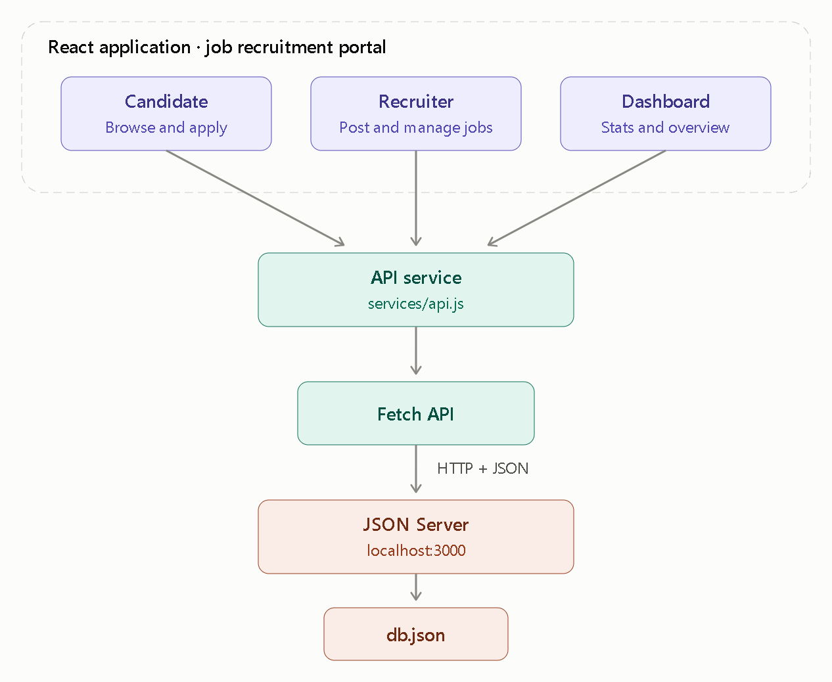

Components in each side:
- Candidate side:
• Register as a candidate
• Search jobs
• Filter jobs by:
- Job title
- Location
- Experience
• View job details
• Apply for a job
• View application status
2)Recruiter side:
• Add a job
• View jobs
• Edit job
• Delete job
• View applications
• Update application status

4. Main pages
Page | Purpose
- Home | Introduction and navigation
- Jobs | Display/search all jobs
- Job Details | Show complete job information
- Candidate Registration | Register candidate
- My Applications | Candidate's applications/status
- Recruiter Dashboard | Manage jobs
- Add/Edit Job | Job form
- Applications | Recruiter views applications

5. API endpoints
- Jobs:
- GET /jobs
- GET /jobs/:id
- POST /jobs
- PUT /jobs/:id
- DELETE /jobs/:id

- Candidate:
- GET /candidates
- GET /candidates/:id
- POST /candidates
- PUT /candidates/:id
- DELETE /candidates/:id
- Application:
- GET /applications
- GET /applications/:id
- POST /applications
- PUT /applications/:id
- DELETE /applications/:id

Jobs — 5 APIs
These are used to manage job postings.
# | Method | Endpoint | Used for
1 | GET | /jobs | Get all available jobs
2 | GET | /jobs/:id | Get details of one job
3 | POST | /jobs | Recruiter adds a new job
4 | PUT | /jobs/:id | Recruiter edits a job
5 | DELETE | /jobs/:id | Recruiter deletes a job

2. Candidates — 5 APIs
These are used to manage candidate information.
# | Method | Endpoint | Used for
6 | GET | /candidates | Get all candidates
7 | GET | /candidates/:id | Get one candidate
8 | POST | /candidates | Register a candidate
9 | PUT | /candidates/:id | Update candidate details
10 | DELETE | /candidates/:id | Delete candidate

3. Applications — 5 APIs:
# | Method | Endpoint | Used for
11 | GET | /applications | View all applications
12 | GET | /applications/:id | View one application
13 | POST | /applications | Candidate applies for a job
14 | PUT | /applications/:id | Update application status
15 | DELETE | /applications/:id | Delete an application

Next routers:
……..

